Grade

# Author = Darren Isaacson

# This code will determine your grade

# Enter in score

score = float(input("Enter quiz score"))

# Generates the score grade and displays output

if score >= 90 :

print("A grade")

elif score >= 80 :

print("B grade")

elif score >= 70 :

print("C grade")

elif score >= 60 :

print("D grade")

else :

print("You failed")

print("\nEnd of program")

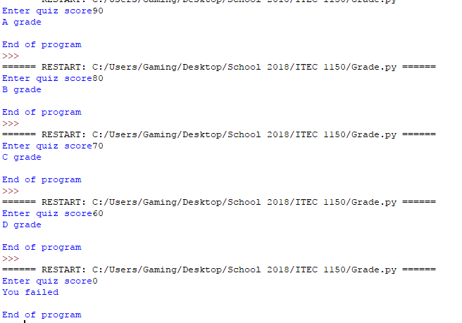

Apollo

# Author = Darren Isaacson

# This program is designed to define if a question is right or wrong

# This function asks the question

year = int(input("When did Apollo 11 land on the moon"))

# This defines if the answer from the input was correct

if year == 1969 :

print("Correct!")

else :

print("Sorry, wrong answer")

print("End of program")

# This function is a variation of the first code

# This function asks the user for a number question

year = int(input("When did Apollo 11 land on the moon?"))

# This if the answer is not 1969 then it is wrong

if year != 1969 :

print("Sorry, wrong answer")

# Any other answer is right

else :

print("Correct!")

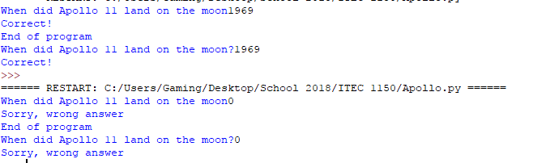

If-1 Program

# Author = Darren Isaacson

# This program is designed

# Asks the user how much money they have

money = int(input("What is the total amount of cents do you have"))

# Defines if the user has more, less, equal, or no money and displays output

if money > 100 :

print("You have more than a dollor")

elif money == 100 :

print("You have exactly a dollar")

else:

print("You have less than a dollar")

print("End of program")

